**Ideas for Inclusion in Music**

Start with the music activity the class is doing. How will all students participate in the activity? If a student has multiple and complex disabilities, what active role can they take? Next, consider adapting the materials or processes to enhance participation. Finally, add specialized equipment to further enhance participation.

Taking a role in a group:

* Provide introductions to the songs using AAC
* Use a spinner to select the song or instrument for the group
* Gather instruments for a group activity
* Work with a group to rehearse for a concert or performance

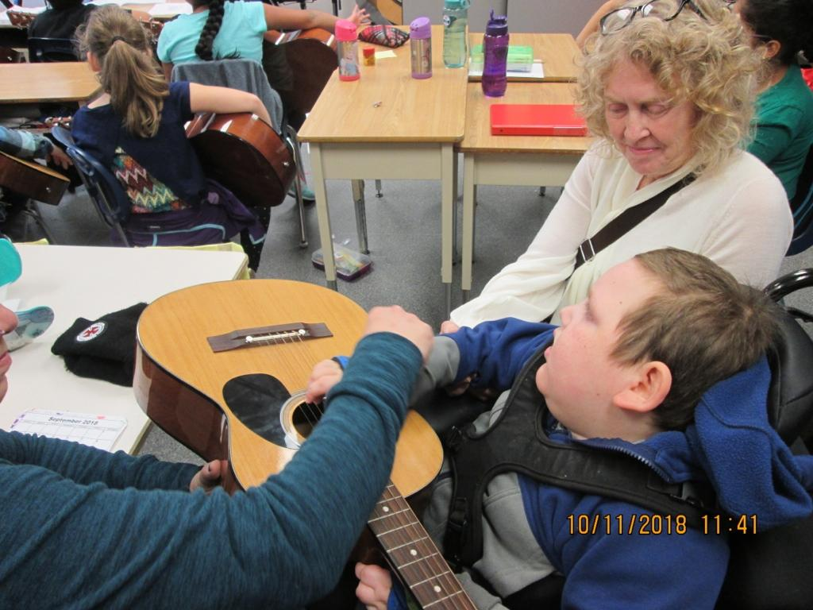

Adapt the materials:

* Drums, bells, sticks, maracas may need minimal adaptations
* Large handles or build up handles with cylindrical foam can assist grasp on hand held instruments
* A universal cuff or EZ hold grip can be added to handles for a student who needs assistance to grasp
* Larger instruments may need to be stabilized on a table
* Large 5 gallon buckets can make simple drums

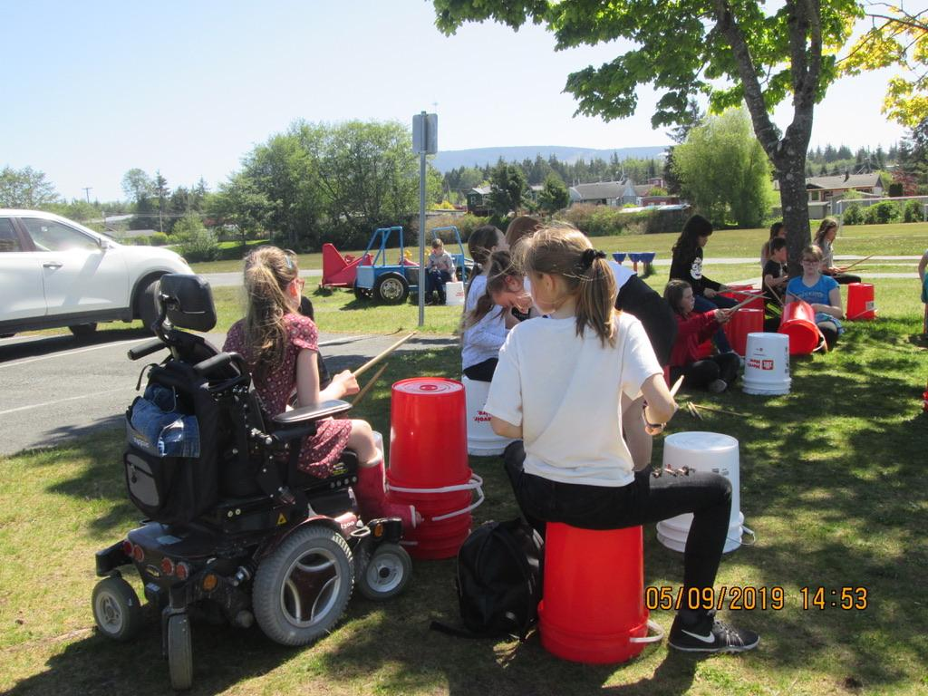

Use a special equipment or apps:

* Can Tunes app to start and stop the music
* Garage Band app can be used as a substitute instrument or to mix recorded music
* Waveband app can be used on an ipod or phone using an exercise strap worn on the student’s wrist or ankle. Any movement of the limb operates the sound.